Design Document - The Exam Cram

This program was designed to help high school students study for their exams and improve their basic knowledge skills. Each student will have their own account accessible through their student number. Once in, they have the option of going through practice questions for each subject or doing a final review test. This program will also contain brief information on subjects such as equations for physics or definitions of computer science terminology. If they choose they can also practice their mental math abilities.

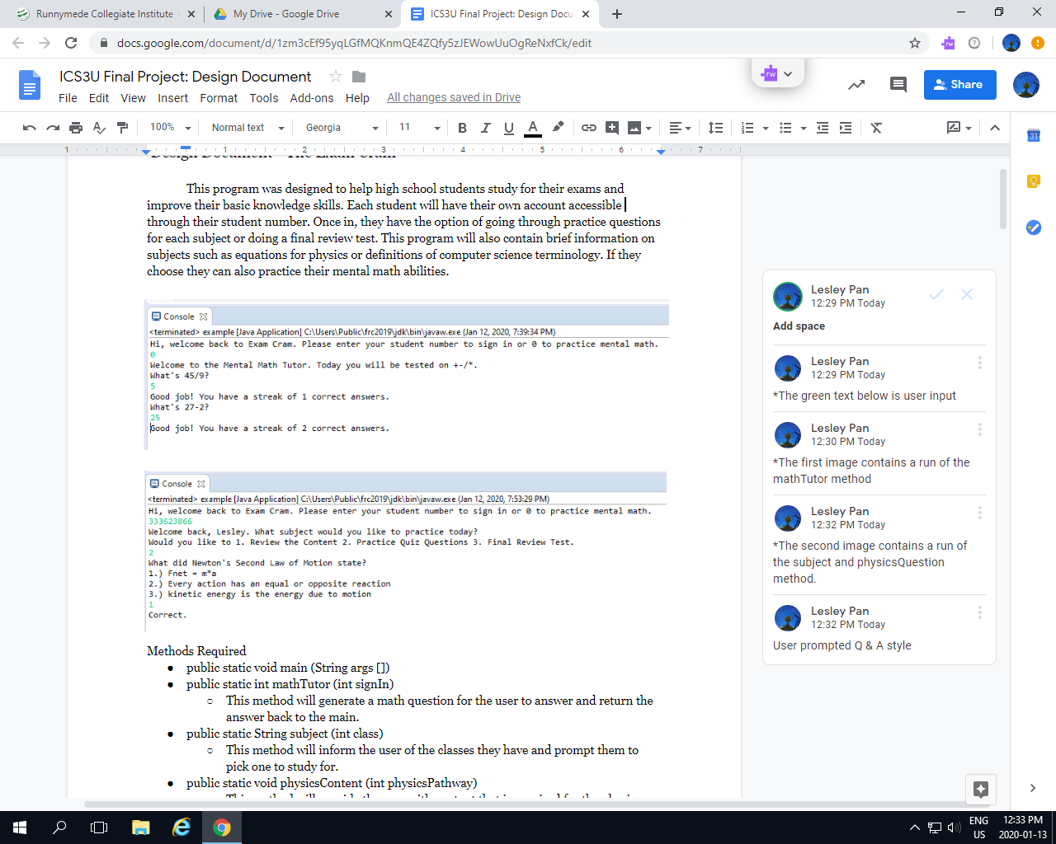

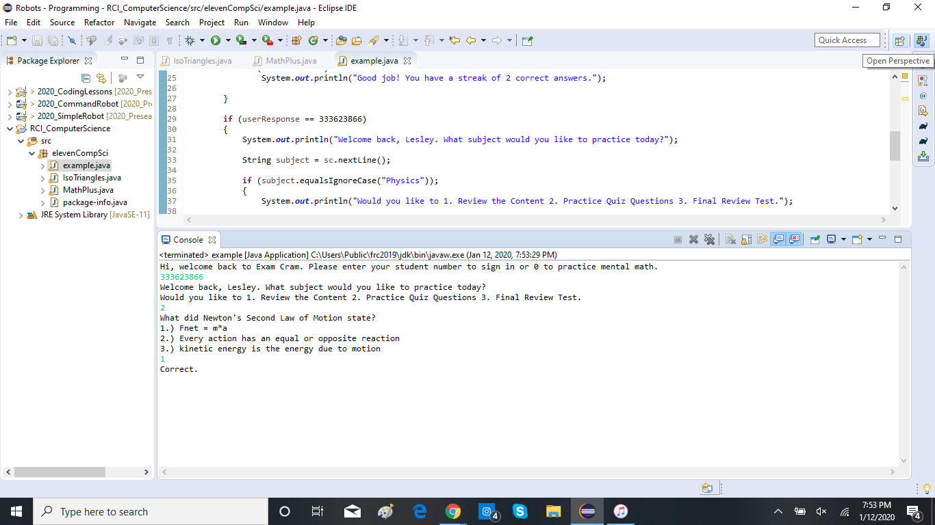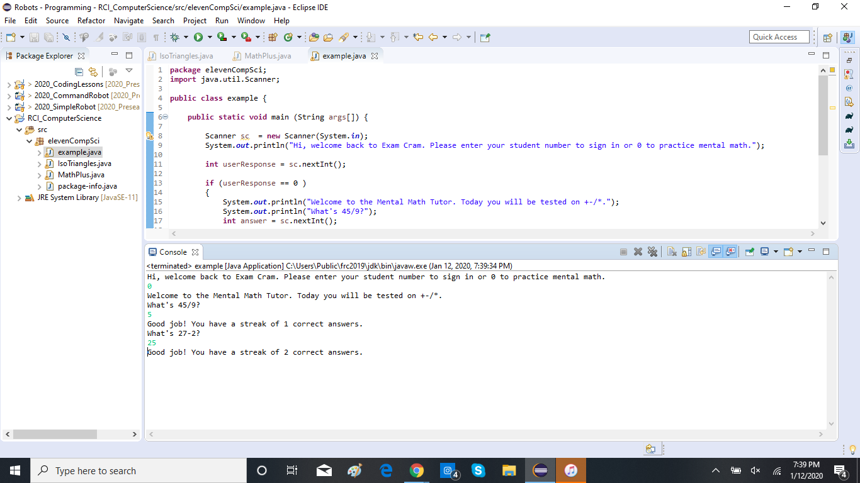

Methods Required

* public static void main (String args [])
* public static int mathTutor (int signIn)
  + This method will generate a math question for the user to answer and return the answer back to the main.
* public static String subject (int class)
  + This method will inform the user of the classes they have and prompt them to pick one to study for.
* public static void physicsContent (int physicsPathway)
  + This method will provide the user with content that is required for the physics class
* public static int physicsQuestions (int physicsPathway)
  + This method will generate a physics multiple choice questions for the user to answer and return the answer to the main
* public static int physicsTest (int physicsPathway)
  + This method will provide the user with a series of questions for them to answer and return the answers to the main.
* public static void SAPContent (int SAPPathway)
  + This method will provide the user with content that is required for the physics class
* public static int SAPQuestions (int SAPPathway)
  + This method will generate a physics multiple choice questions for the user to answer and return the answer to the main
* public static int SAPTest (int SAPPathway)
  + This method will provide the user with a series of questions for them to answer and return the answers to the main.
* public static void CSContent (int CSPathway)
  + This method will provide the user with content that is required for the physics class
* public static int CSQuestions (int CSPathway)
  + This method will generate a physics multiple choice questions for the user to answer and return the answer to the main
* public static int CSTest (int CSPathway)
  + This method will provide the user with a series of questions for them to answer and return the answers to the main.

Pseudocode

public static void main (String args [])

{

print Welcome to the Exam Cram. Please enter your student number to continue or 0 to practice mental math.

Int signIn = sc.nextInt();

If (signIn == 0)

{

print if you would ever like to exit the math tutor, enter pi or 3.14

Int counter = 0;

do

mathTutor(signIn);

Int userMathAnswer = sc.nextInt();

If (userMathAnswer == answer}

Counter ++;

Print good job, you’ve answered counter amount of questions correctly;

Else

Counter = 0

Print sorry the right answer was answer.

While userMathAnswer != 3.14

Print Welcome back UserName.

Int class = 3;

subject(class);

String userSubject = sc.nextLine();

Do

If (userSubject.equals(physics))

{

print Would you like to 1.) review content, 2.) practice questions, 3.) final review test

Int physicsPathway = sc.nextInt();

If (physicsPathway == 1)

For (i = 10; 10<1; i++)

{

physicsContent(physicsPathway);

Print would you like to try something else yes/no

Int userPhysicsChange = sc.nextLine();

if (userPhysicsChange.equalsIgnoreCase(“yes”)

Break;

}

Else if (physicsPathway == 2)

For (i = 10; 10<1; i++)

{

physicsQuestions(physicsPathway);

Int userPhysicsQuizAnswer = sc.nextInt();

If ( userPhysicsQuizAnswer == physicsQuizAnswer)

Print Good job that’s the right answer

Else

Print almost the answer was physicsQuizAnswer

Print would you like to try something else yes/no

Int userPhysicsChange = sc.nextLine();

if (userPhysicsChange.equalsIgnoreCase(“yes”)

Break;

}

Else

double physicsTestCounter = 0;

For (i = 0; i<physicsTestArray.length; i++)

{

physicsTest(physicsPathway);

Int userPhysicsTestAnswers = sc.nextInt();

If (userPhysicsTestAnswes == PhysicsTestAnswers)

Counter ++

}

Double percentage = counter/totalQuestions \* 100;

Print you got a percentage % on this test. The answers were print the array of answers.

Print would you like to try something else yes/no

Int userPhysicsChange = sc.nextLine();

if (userPhysicsChange.equalsIgnoreCase(“yes”)

Break;

}

Print would you like to change your subject 1 for yes 2 for no

boolean change = false;

Int userChange = sc.nextInt();

If (userChange == 1)

Change = true;

While change = false;

Do

If (userSubject.equals(SAP))

{

print Would you like to 1.) review content, 2.) practice questions, 3.) final review test

Int SAPPathway = sc.nextInt();

If (SAPPathway == 1)

For (i = 10; 10<1; i++)

{

SAPContent(SAPPathway);

Print would you like to try something else yes/no

Int userSAPChange = sc.nextLine();

if (userSAPChange.equalsIgnoreCase(“yes”)

Break;

}

Else if (SAPPathway == 2)

For (i = 10; 10<1; i++)

{

SAPQuestions(SAPPathway);

Int userSAPQuizAnswer = sc.nextInt();

If ( userSAPQuizAnswer == SAPQuizAnswer)

Print Good job that’s the right answer

Else

Print almost the answer was SAPQuizAnswer

Print would you like to try something else yes/no

Int userSAPChange = sc.nextLine();

if (userSAPChange.equalsIgnoreCase(“yes”)

Break;

}

Else

double SAPTestCounter = 0;

For (i = 0; i<SAPTestArray.length; i++)

{

SAPTest(SAPPathway);

Int userPhysicsTestAnswers = sc.nextInt();

If (userSAPTestAnswes == SAPTestAnswers)

Counter ++

}

Double percentage = counter/totalQuestions \* 100;

Print you got a percentage % on this test. The answers were print the array of answers.

Print would you like to try something else yes/no

Int userSAPChange = sc.nextLine();

if (userSAPChange.equalsIgnoreCase(“yes”)

Break;

}

Print would you like to change your subject 1 for yes 2 for no

change = false;

Int userChange2 = sc.nextInt();

If (userChange2 == 1)

Change = true;

While change = false;

Do

If (userSubject.equals(CS))

{

print Would you like to 1.) review content, 2.) practice questions, 3.) final review test

Int CSPathway = sc.nextInt();

If (CSPathway == 1)

For (i = 10; 10<1; i++)

{

CSContent(CSPathway);

Print would you like to try something else yes/no

Int userCSChange = sc.nextLine();

if (userCSChange.equalsIgnoreCase(“yes”)

Break;

}

Else if (CSPathway == 2)

For (i = 10; 10<1; i++)

{

CSQuestions(CSPathway);

Int userCSQuizAnswer = sc.nextInt();

If ( userCSQuizAnswer == CSQuizAnswer)

Print Good job that’s the right answer

Else

Print almost the answer was CSQuizAnswer

Print would you like to try something else yes/no

Int userCSChange = sc.nextLine();

if (userCSChange.equalsIgnoreCase(“yes”)

Break;

}

Else

double CSTestCounter = 0;

For (i = 0; i<CSTestArray.length; i++)

{

CSTest(CSPathway);

Int userPhysicsTestAnswers = sc.nextInt();

If (userCSTestAnswes == CSTestAnswers)

Counter ++

}

Double percentage = counter/totalQuestions \* 100;

Print you got a percentage % on this test. The answers were print the array of answers.

Print would you like to try something else yes/no

Int userCSChange = sc.nextLine();

if (userCSChange.equalsIgnoreCase(“yes”)

Break;

}

Print would you like to change your subject 1 for yes 2 for no

change = false;

Int userChange2 = sc.nextInt();

If (userChange2 == 1)

Change = true;

While change = false;